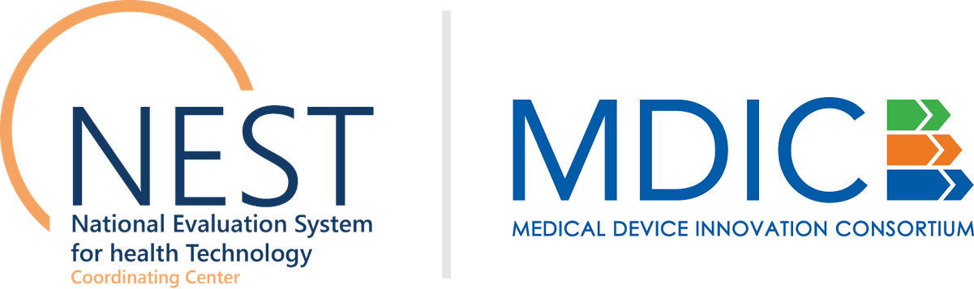
NEST Coordinating Center
www.nestcc.org

Posting Date: July 12, 2018
Public Information Webinar: July 27, 2018
Due Date: September 19, 2018

National Evaluation System for health Technology Coordinating Center (NESTcc)
Second Round of Call for Concepts: An Invitation to Submit Concepts for Real-World Evidence Test-Cases
Concept Submission Form Template
Instructions
Please provide the information requested below. Send your completed form as a PDF along with any other relevant documentation to NESTcc@mdic.org by September 19, 5p.m. EST. Your Concept Proposal must not exceed two (2) pages. Please note that you may delete italicized instructional text.

Administrative Information
Indicate a primary contact and affiliated organization. Any additional administrative information may be provided by adding additional fields to the table. All communications regarding this form will be directed to the primary contact outlined in the form.

Required Field | Information
Primary Contact, Title
Primary Contact E-mail
Primary Contact Phone Number
Organization
Organization Type
(industry including medical device associations or multi-manufacturer initiatives, health systems and health payers)
Organization Address
Organization Description (including size)
[ADD ADDITIONAL ROWS IF NEEDED]

Concept Proposal
Concept proposals must not exceed two (2) pages and submitters are not required to use the full space allowable.

- Test-Case Description

☐ Yes, this is a project extension. | Please check the box to indicate if the concept proposed in this submission is an extension of a current test-case utilizing the NESTcc Data Network. Please describe how the project will build off the previously selected project.

- Provide a description of the proposed test-case. Include a description of the medical technology of interest and a description of the population of interest.
- Describe the data sources that would be collected and analyzed for the study – data originating from registries, electronic health records (EHRs), claims, and other electronic data such as Patient-Generated Health Data (PGD) that may include patient-reported outcomes (PROs) and Patient Preference Information (PPI).
- Describe ways patient input could be used to inform the clinical study design so that patient participation barriers are reduced and recruitment retention is increased.
- Describe the proposed study design (whether it would be a retrospective or prospective study) and how it may support any use case across the Total Product Life Cycle (TPLC) as defined below:
Pre-Market (i.e, PMA, 510(k), De Novo): Using RWE to inform pre-market development of incremental improvement of medical devices.
Label Expansion: Using RWE in a regulatory submission to support an expanded indication for use of medical devices already on the market.
Post-Market Approval Studies (PAS): Using generated RWE to track medical device’s safety and effectiveness as part of its condition of approval.
Surveillance: Using generated RWE to track and document medical device safety and effectiveness for products on the market.
Coverage: Using generated RWE to support coverage and reimbursement decisions by public and private payers.
NESTcc is interested in devices subject to approval or clearance pathways, Class II and III devices, as well as imaging and diagnostic technologies (IVDs), and technologies used in cancer. The concepts should be new projects that are not currently underway. Please note, priority will be given to test-cases focused on imaging or diagnostic technologies in this round.

- Alignment
- Provide a description of how the test-case aligns with the initiative goals to:
  - Explore the feasibility for key stakeholders in the medical device ecosystem to use Real-World Data sources (i.e., electronic health records, public and private claims, registries, and patient-generated health data) offered by NESTcc’s Network Collaborators.
  - Contribute to NESTcc’s development of operational processes (e.g., contracting, IRB, data sharing agreements, publication policies).
- Describe how the test-case aligns to NESTcc’s strategic priorities and the Total Product Life Cycle.
- Describe the added benefit of working collaboratively with NESTcc to execute this test-case.

- Other Information to Include
  - As part of the application, NESTcc will also request that partners describe the availability of in-house data sources that could be used in the study (e.g., device generated data, list of procedures using the device of interest, etc.). Actual data should not be shared with NESTcc at the time of the concept submission.
  - NESTcc is looking for the best way to involve the FDA in the progress of the test-cases. Please provide a brief description of interactions your organization has held with the FDA up until this point and/or planned future interactions, as it relates to these specific projects.

Attachments
Include any relevant attachments. There are no required attachments.

